**Diploma in Geriatric Medicine - Communications Toolkit**

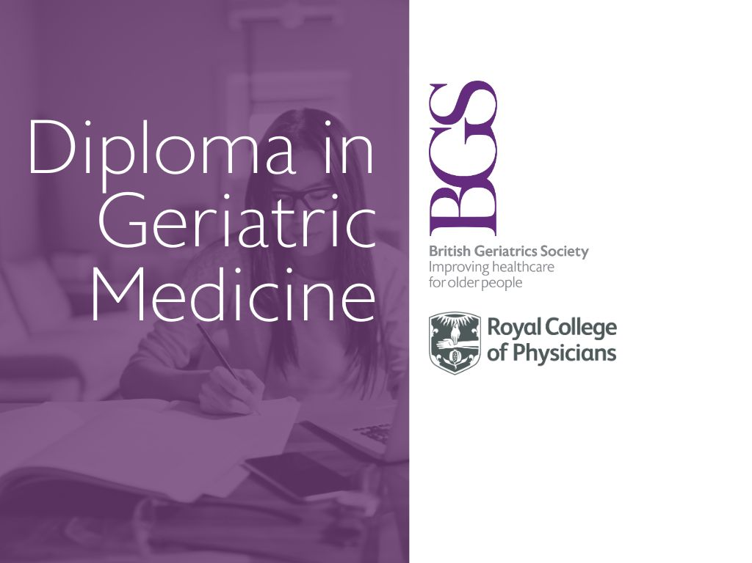*For the attention of communications/PR team or relevant member of staff*

The Diploma in Geriatric Medicine (DGM), awarded by the Royal College of Physicians, is designed for individuals who want to demonstrate their knowledge and expertise in the healthcare of older people.

What this Communications Toolkit contains:

* Suggested copy for social media, e-bulletins, newsletters and in-house publications.
* Two promotional JPEGs for use on websites and social media

Overview:

The Diploma in Geriatric Medicine (DGM), awarded by the Royal College of Physicians (RCP), is an examination developed collaboratively by the RCP and the British Geriatrics Society. It is designed for individuals who want to demonstrate their knowledge and expertise in the healthcare of older people.

BGS URL: <https://www.bgs.org.uk/DGM>  
RCP URL: <https://www.rcplondon.ac.uk/diploma-geriatric-medicine>

Why your organisation should promote the DGM

The UK’s population is ageing. The number of people over the age of 65 years increased from 9.2 million in 2011 to [over 11 million](https://www.ons.gov.uk/peoplepopulationandcommunity/birthsdeathsandmarriages/ageing/articles/profileoftheolderpopulationlivinginenglandandwalesin2021andchangessince2011/2023-04-03) in 2021 and the proportion of people aged 65 years and over rose from [16.4% to 18.6%](https://ons.gov.uk/peoplepopulationandcommunity/birthsdeathsandmarriages/ageing/articles/voicesofourageingpopulation/livinglongerlives). Patients aged 65 to 69 make up the single [largest group of hospital admissions](https://digital.nhs.uk/news/news-archive/2016-news-archive/hospital-admissions-hit-record-high-as-population-ages#:~:text=Patients%20aged%2065%20to%2069%20made%20up%20the%20single%20largest,includes%20babies%20born%20in%20hospital.). [Diploma in Geriatric Medicine](https://www.bgs.org.uk/DGM) (DGM) will help your members demonstrate their knowledge, skills and understanding of managing frailty and the chronic conditions experienced by older people.

Suggested copy for social media, e-bulletins, in-house publications and websites

* Twitter:

The Diploma in Geriatric Medicine, developed by @gerisoc and @RCPhysicians, is designed for individuals who want to demonstrate their knowledge and expertise in the healthcare of older people. Could it be right for you? Find out more <https://www.bgs.org.uk/DGM>

Are you looking to demonstrate your expertise in older people's healthcare? Look no further. Developed by @gerisoc and @RCPhysicians, the Diploma in Geriatric Medicine is open to {speciality name} Find out more here <https://www.bgs.org.uk/DGM>

* Facebook/Instagram/LinkedIn:

Are you looking to demonstrate your expertise in older people's healthcare? Look no further. The Diploma in Geriatric is a credential that recognises the in-depth critical understanding, clinical knowledge and skills required in the field of geriatric medicine to provide expert care for older people. Candidates sit two examinations: an online knowledge-based assessment, and a clinical exam, currently taken in person at the RCP’s Examination Assessment Centre in Liverpool. Find out more here <https://www.bgs.org.uk/DGM>

* e-Bulletins/e-Newsletters:

If you're a member of the multidisciplinary team involved in the provision of care of older people and want to demonstrate your knowledge, skills and understanding of managing frailty and the chronic conditions experienced by older people, the DGM provides a recognised, well-regarded award. You might be working in community, primary or secondary care, and you will have had at least two years’ post-qualification experience, at least four months of which will be in a setting where you have interacted with a large number of older people. You’ll be familiar with developing care plans for older people Find out more here <https://www.bgs.org.uk/DGM>

Promotional jpegs for use on websites and social media

* JPEG 1 URL:

<https://www.bgs.org.uk/sites/default/files/content/DGM%20image%20one.jpg>

* JPEG 2 URL:

<https://www.bgs.org.uk/sites/default/files/content/DGM%20image%20two.jpg>

For further information please contact the British Geriatrics Society:

Marina Mello  
Communications, PR and Media Manager  
Direct Line: +44 (0)207 608 8572  
Out of hours: +44 (0)7850271579  
Email: [m.mello@bgs.org.uk](mailto:m.mello@bgs.org.uk)